QUAID-E-AWAM UNIVERSITY OF ENGINEERING, SCIENCE & TECHNOLOGY, NAWABSHAH
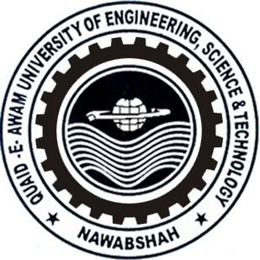

MID-SEMESTER examination OF first SEMESTER – first year (1st SEMESTER) 2022, 21-BATCH, b.S (it)
SUBJECT: pre-calculus-i

Dated: 21.02.2022 Maximum Marks: 20 Time Allowed: 01 Hour.

NOTE: attEMPT ANY TWO (02) questions. all questions carry equal marks.

Q. No. | QUESTION | CLOs | Taxonomy Level | PLOs | Marks
Q. 01
Q. 02
Q. 03

Good Luck

Q. No. |  | Question | CLOs | Taxonomy Level | PLOs | Marks
Q. 01 | (a)
 | (b)
Q. 02 | (a)
 | (b)
Q. 03 | (a)
 | (b)

The End

