QUAID-E-AWAM UNIVERSITY OF ENGINEERING, SCIENCE & TECHNOLOGY, NAWABSHAH
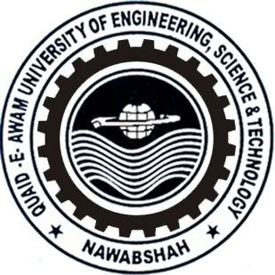

FINAL SEMESTER regular examination OF second SEMESTER – second year, 2019 OF F-18-BATCH, b.e (cs)
SUBJECT: professional & social ethics

Dated: 30.03.2019 Maximum Marks: 30 Time Allowed: 02 Hours.

NOTE: attEMPT ALL questions. all questions carry equal marks.

Q. 01 | (a)
 | (b)
Q. 02 | (a)
 | (b)
Q. 03 | (a)
 | (b)
Good Luck

QUAID-E-AWAM UNIVERSITY OF ENGINEERING, SCIENCE & TECHNOLOGY, NAWABSHAH

FINAL SEMESTER regular examination OF first SEMESTER – second year, 2019 OF F-18-BATCH, B.E (ch)
SUBJECT: physical & analytical chemistry

Dated: 05.04.2019 Maximum Marks: 60 Time Allowed: 3 Hours.
NOTE: attEMPT ALL questions. all questions carry equal marks.

Q. 01 | (a)
 | (b)
Q. 02 | (a)
 | (b)
Q. 03 | (a)
 | (b)
Q. 04 | (a)
 | (b)
Q. 05 | (a)
 | (b)

The End

QUAID-E-AWAM UNIVERSITY OF ENGINEERING, SCIENCE & TECHNOLOGY, NAWABSHAH

FINAL SEMESTER regular examination OF second SEMESTER - second year, 2019 OF F-18-BATCH, B.S (it)
SUBJECT: visual programming (objective test)

Dated: 30.03.2019 Maximum Marks: 10 Time Allowed: 20 Minutes.
ID No. ___________________
Marks obtained in figures: ________________ Sign of Internal Examiner ________

Marks obtained in words: _________________ Sign of External Examiner ________

choose the correct answer:
1
2
3
4
5
6
7
8
9
10
tick true or false:
11
12
13
14
15
write formulae of the following:
16
17
18
19
20

The End

